**Project Design Phase-II**

**Data Flow Diagram & User Stories**

| Date | 1 July 2025 |
| --- | --- |
| Team ID | LTVIP2025TMID49753 |
| Project Name | Heritage Treasures: An In-Depth Analysis of UNESCO World Heritage Sites |
| Maximum Marks | 4 Marks |

**Data Flow Diagrams:**

A Data Flow Diagram (DFD) is a traditional visual representation of the information flows within a system. A neat and clear DFD can depict the right amount of the system requirement graphically. It shows how data enters and leaves the system, what changes the information, and where data is stored.



**Example:** [**(Simplified)**](https://developer.ibm.com/patterns/visualize-unstructured-text/)

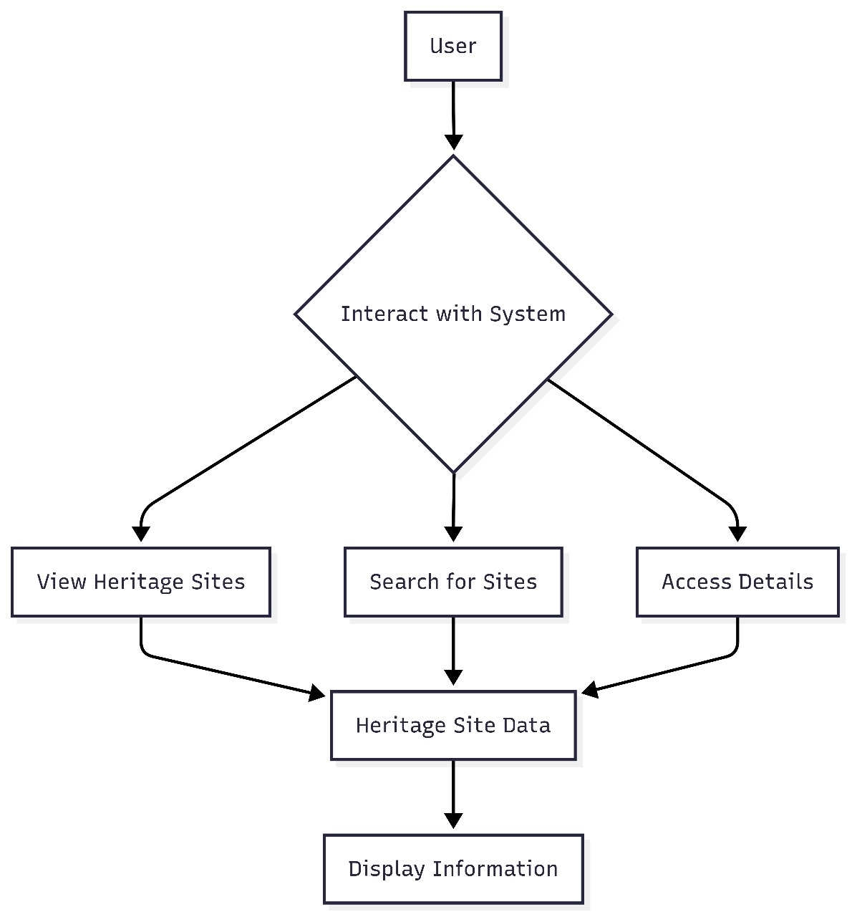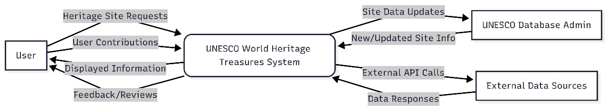

**User Stories**

Use the below template to list all the user stories for the product.

| **User Type** | **Functional Requirement (Epic)** | **User Story Number** | **User Story / Task** | **Acceptance criteria** | **Priority** | **Release** |
| --- | --- | --- | --- | --- | --- | --- |
| Visitor / Tourist  (Web) | Registration | USN-1 | As a user, I can register with my email, password, to access UNESCO site daat | I can access an account / dashboard and receive confirmation | High | Sprint-1 |
| Visitor / Tourist  (Web) | Login | USN-2 | As a user, I can log in using my credentials | I can Login and see the home page / dashboard | High | Sprint-1 |
| Visitor / Tourist  (Web) | Dashboard | USN-3 | As a user, I can exploreUNESCO sites using charts and maps | I can interact with graphs and get site-specific details | High | Sprint-2 |
| Visitor / Tourist  (Web) | Storyboard | USN-4 | As a user, I can view heritage stories for selected sites | I can view the full storyboard with navigation | Medium | Sprint-2 |
| Administrator | Content Upload | USN-5 | As an admin,I can upload or update site data to the dashboard | i can see updated data reflected in dashboards and storyboards | High | Sprint-3 |
| Visitor / Tourist  (Web) | Contact | USN-6 | As an user, I can view contact details and send a message through the contact form | I receive a success message after submitting the form | Medium | Sprint-2 |
| Administrator | UserManagement | USN-7 | As an admin,I can manage user accounts | I can update user status and see changes reflected | Low |  |
|  |  |  |  |  |  |  |
|  |  |  |  |  |  |  |
|  |  |  |  |  |  |  |
|  |  |  |  |  |  |  |
|  |  |  |  |  |  |  |